Computer Systems 414 13 April 2021

Walt Deyzel: 21750793

**Code:**

Busy wait method.

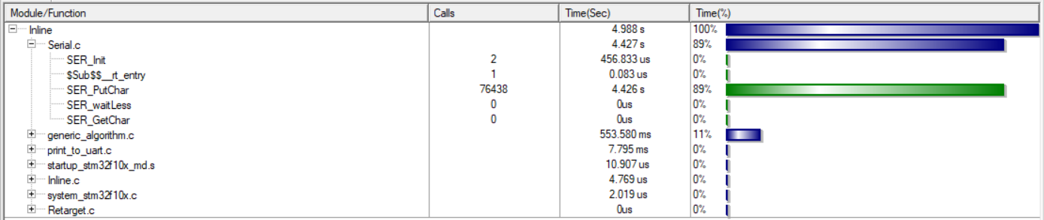

Flag control print method

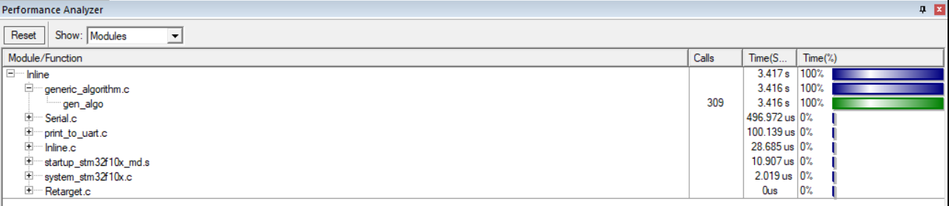

Busy Wait

Flag control

|  |  |
| --- | --- |
| The ***busy wait*** method writes the entire message via **UART** before executing the generic algorithm method that simulates the CPU tracking of the IP address. This uses 89% of the program execution time according to the performance analyser to send the message and 11% to track the IP address.  The ***Flag control*** method sends ***one character*** at a time (keeping track of index via static int) from the message then executes the generic algorithm method that simulates the CPU tracking of the IP address. This method uses basically 0% of the execution time to send the message which leaves approximately 100% of the execution performance to the CPU. Making it a more efficient method to track the IP address but takes longer to send the message to the person on the other end of the connection.  A better method would be to run both the generic algorithm and sending message function in parallel. So that neither function must wait for the other to finish. |  |